**Technical Documentation – Deploy_Digital_Services – Developers VERSION**

1. Workflow – Deploys Digital Services Artifacts to Digital Services **TEST** servers, tbusserv3bcp and tbusserv4bcp. This workflow is to be launched by the Digital Services Developers.

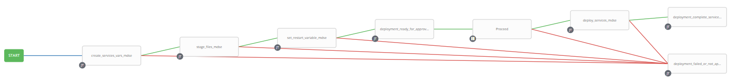

In order to launch the workflow, the Developer has to be part of the Ansible Tower Team ‘Digital Services Developers’. If the developer is already a user of Ansible Tower their Active Directory Userid can be easily added to the Team. If the developer is not currently a user of Ansible Tower they will have to login to the Production Ansible Tower Instance (<https://pdeploy1bcp.penc.local/#/templates>) using either Firefox or Chrome (Internet Explorer will NOT work). After the developer has logged in the PENC_ITS_TSS_Midtier group needs to be contacted to add the developer to the Team. The PENC_ITS_TSS_Midtier group also has to add the developers email address to the {{mail_list}} in the Extra Vars section of the workflow template.

The QA Team needs to approve deployments into the Digital Services TEST Environments. In order to approve deployments the Tester needs to be a member of the Ansible Tower Team ‘Digital Services Quality Assurance’. Registration process is identical to the developer process above.

Once the developer launches the workflow an email message with a link to the workflow launched is sent to all of the developers and testers defined in the {{mail_list}} in the Extra Vars section of the workflow template.

The Tester brings up the link in the email and approves the workflow. The workflow then proceeds to deploy the artifacts to the Digital Services TEST servers.

Should any job within the template fail or the Tester ‘Denies’ the approval, an email is sent to the {{mail_list}} informing the recipients of the failure and it not being approved.

1. Survey – User Supplied Variables

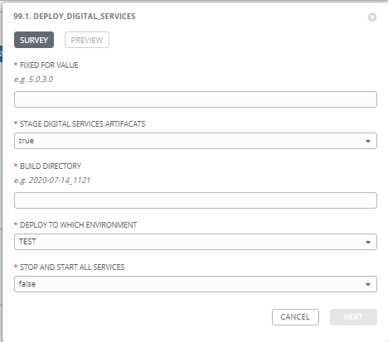

|  |  |  |  |
| --- | --- | --- | --- |
| **Survey Extra Variables** | **Prompt** | **Type** | **Description and Usage** |
| FFV | Fixed For Value | Text | The fixed for value for the deployment – must be of the format ###.###.###.### (i.e. 58.0.12.0). Numbers only, with a maximum of 3 digits and there must be 4 sets separated with a ‘.’. Used to create staging and deployments directories. Used by all job templates in the workflow |
| STAGE | Stage Digital Services Artifacts | Multiple Choice Single Pick | True or false – Copies the Digital Services Artifacts from the MDSE Build Releases Directory to the Staging folder. |
| ReleaseDir | Build Directory | Text | The /pencmw_common/MDSE/releases/ subdirectory that contains the business services artifacts |
| ENV | Deploy to Which Environment | Multiple Choice Single Pick | The Environment to Deploy to: MAINT or PROD. Only a single environment can be deployed to per workflow execution |
| SERVICES_RESTART | Stop and Start All Services | Multiple Choice Single Pick | True or false – Restarts ALL Digital Services. This can be kept as ‘false’ and the deployment workflow will decide whether all of the digital services need to be restarted or just the newly deployed services. It should only be set to ‘true’ if the developer has decided that ALL services need to be restarted. |

1. Jobs Used by the workflow - http://owl.penc.local:18080/svn/deploy_automation/trunk/Ansible_PlayBooks/MDSE

|  |  |  |  |
| --- | --- | --- | --- |
| **Job Template** | **Ansible Playbook** | **Project** | **Description and Usage** |
| create_services_vars_mdse | create_services_vars_mdse.yml | MDSE Deployments | Creates Variables/Artifacts for use within the workflows, based on the User supplied survey results.  Artifacts Defined with examples  DeploymentLogDir: /codemove_common/dp_automation/deployments/001.000/001.000.004.000/MDSE  RESTART_ALL: false  StageDir: /codemove_common/dp_automation/stage/001.000/001.000.004.000/MDSE  date_time: '20200901_1447'  services_deployment_host: 'tbusserv3bcp,tbusserv4bcp'  stage_server: diagoras1bcp  tower_hostname: pdeploy1bcp.penc.local |
| stage_files_mdse | stage_files_mdse.yml | MDSE Deployments | Copies MDSE Services Artifacts from /pencmw_common/MDSE/releases/{{ReleaseDir}} to the {{StageDir}}/{{ReleaseDir}}  The job fails if the /pencmw_common/MDSE/releases/{{ReleaseDir}} build directory does not exist.  If the stage_server is set to ‘none’ as opposed to diagoras1bcp, the playbook does not do anything, all of the tasks are skipped.  The last task of the job creates a Staging Report in the {{DeploymentLogDir}} in html format. |
| set_restart_variable_mdse | set_restart_variable_mdse.yml  calls:  check_for_key_jars_mdse.yml | MDSE Deployments | Loops through all the jar files in {{StageDir}}/{{ReleaseDir}} with the check_for_key_jars_mdse.yml playbook and if any jar file is one of penc-config-srv.jar, penc-hub-srv.jar, penc-security-srv.jar or penc-gateway-srv.jar set the {{RESTART_ALL}} to true.  If the User has set {{SERVICES_RESTART}} to true set {{RESTART_ALL}} to true. |
| deploy_services_mdse | deploy_services_mdse.yml  CALLS:  shutdown_mdse_services.yml when {{RESTART_ALL}} is true  deploy_single_service_mdse.yml  startup_mdse_services.yml when {{RESTART_ALL}} is true | MDSE Deployments | deploy_services_mdse.yml, if {{RESTART_ALL}} is true, it stops all of the services with specific shutdown tasks for the gatewayservice, securtiyservice, hubservice and configserve, then calls shutdown_mdse_services for all other services.  deploy_services_mdse.yml then calls deploy_single_service_mdse.yml by looping through the jar files in {{StageDir}}/{{ReleaseDir}}. If {{RESTART_ALL}} is false the service will be stopped, deployed and then started. If {{RESTART_ALL}} is true all of the services have already been shutdown so the jar file is just deployed.  If {{RESTART_ALL}} is true deploy_services_mdse.yml, starts the configservice, hubservice, securityservice and gatewayservice in a specific order. It also checks ports 18000 and 18001 to ensure the config and hub services are started before proceeding. If {{RESTART_ALL}} is true it then calls startup_mdse_services.yml to start the rest of the services.  The playbook operates in serial mode so it deploys to a single server at a time (i.e. no outage in a load balanced environment) |
| deployment_complete_services_mdse | deployment_complete_services_mdse.yml | MDSE Deployments | Populates an html formatted deployment log {{DeploymentLogDir}}/{{ReleaseDir}}/{{ENV}}_MDSE_{{date_time}}.html |